**Bird migration connects regions but does not raise local prevalence and richness of avian haemosporidian parasites**

Daniela de Angeli Dutra¹*, Antoine Filion¹, Alan Fecchio², Érika Martins Braga³, Robert Poulin¹

danideangeli@live.com

afilion90@gmail.com

alanfecchio@gmail.com

embraga@icb.ufmg.br

robert.poulin@otago.ac.nz

1. Department of Zoology, University of Otago, Dunedin, New Zealand

2.Programa de Pós-graduação em Ecologia e Conservação da Biodiversidade, Universidade Federal de Mato Grosso, Cuiabá, MT 78060-900, Brazil

3.Departamento de Parasitologia, Instituto de Ciências Biológicas, Universidade Federal de Minas Gerais, Brazil

1.Introduction

Migration has an important impact on the transmission of disease around the world because migrant species can disperse pathogens and parasites between two or more locations and be exposed to more infectious agents (Bauer and Hoye, 2014). In this way, migrant species might play an important role in the evolution and distribution of parasites and promote the spread of pathogens to new areas and new hosts species. Besides that, human introduced pathogens and host species can decrease the fitness and survival of resident and native species, compromising the population abundance of local species and reducing community richness (Callaway and Ridenour, 2004; Prenter et al., 2004). Conversely, the spread of pathogens might increase richness by reducing competition pressures and, therefore, avoiding competitive exclusion. Hence, pathogen spread might act as an environmental filter to new species colonization. Several studies have documented the influence of migratory birds on the spread of important pathogens with some of these able to infect humans (Alekseev et al., 2001; Hellgren et al., 2007; Lindeborg et al., 2012; Morshed et al., 2005; Poupon et al., 2006; Ricklefs et al., 2017). Thus, the migratory behavior of birds may influence directly local richness and population size.

Recently, it was suggested that avian malaria parasites and related haemosporidians, could be used as geographical markers for migratory birds (Marzal, 2012). Previous research has demonstrated differences in the timing of the main occurrence of haemosporidian infection in migrating birds. These studies have suggested that differences in haemosporidian lineages could indicate whether birds had become infected in different areas (Marzal, 2012). Because migratory birds connect distinct geographic regions they might influence local pathogen transmission. Since most haemosporidians cause life-long infections, parasites may travel across long distances with their bird host during migration. This would therefore allow them to infect new vectors and new avian hosts in novel environments (Fecchio et al., 2020). Indeed, migratory species are known for their potential to connect distant habitats and transfer large amounts of biomass and nutrients between ecosystems (Altizer et al., 2011). Furthermore, O’Connor et al. 2020 have demonstrated that migratory birds do not possess higher immune gene richness in wetter areas, which could make them more susceptible to pathogens in those regions. For this reason, it might also be expected that migratory birds harbor a more diverse range of parasites and might be more susceptible to parasite infections.

South America comprises different types of biomes, such as Amazonia, Brazilian Savanna, Atlantic Rain Forest and Pantanal, which hold a great richness of native resident and migratory bird species. Previous research has documented the prevalence of avian malaria in different regions of Brazil, and markedly different prevalence for *Plasmodium* spp have been reported (Braga et al., 2011). In Brazil, the most prevalent avian haemosporidian parasite genus is *Plasmodium* (Braga et al., 2011), however, recently research conducted in Northeast Brazil reported higher prevalence of *Haemoproteus* parasites in this region (unpublished data). *Plasmodium* parasites present higher host-shifting rates (Hellgren et al., 2007), which could certainly contribute to the dissemination of haemoparasites by migratory birds into new areas. Indeed, host-shifting of a *Plasmodium* species from domestic chicken to wild and native birds has already been reported in Brazil (Ferreira-Junior et al., 2018).

Furthermore, the great avian richness (~3000 species) and abundance in South America could also enhance the probability of parasite host-shifting between migratory and resident birds, given the likely presence of susceptible birds in any particular area. Besides that, the great richness and abundance of vectors could also increase the chances of host-shifting between migratory and resident birds as it increases the chances of compatible vectors being present. Ferreira et al., 2016 have identified the potential mosquito vectors of avian haemosporidian parasites in Brazil, revealing *Mansonia* spp. and *Culex* spp. as vectors of *Plasmodium*, and *Psorophora* spp. as vectors of *Haemoproteus*. Thus, these features make the Brazilian avian haemosporidians a great model to investigate the putative transmission of pathogens via host migration in nature.

In this context, the main goal of this study is to evaluate the influence of migratory birds on the spread of haemosporidian parasites in South America. Specifically, we hypothesize that (1) migratory birds spread parasite lineages along their migratory routes, and (2) localities crossed by more migratory routes have greater prevalence and richness of haemosporidian lineages. For the first hypothesis, we tested whether parasite lineages found (i) only in migratory birds, (ii) in both migrants and residents, and (ii) only in residents, differ in their frequency of occurrence among localities. Due to the fact migrants can carry parasites from many sites and infect resident birds, we predicted that parasite lineages using migratory birds will occur in a greater percentage of localities than those using only resident birds. Moreover, migration behavior increases the exposure of birds to more parasites lineages, thus we also expected higher proportion of lineages in migratory than resident birds. For the second hypothesis, we tested for a relationship among localities between the overall local haemosporidian prevalence and species richness, and the proportion of migratory birds passing through a locality.

2. Methods

2.1 Dataset

All the analyses were performed using the MalAvi database (<http://130.235.244.92/Malavi/>) from South American regions and another dataset containing ~13200 bird blood samples from 63 different locations sampled from 2005 to 2018 in South America, mainly in Brazil (Figure 1). Combining both datasets, we obtained a total of ~2800 parasite lineages. The parasite prevalence (*Plasmodium* and *Haemoproteus*) was estimated using PCR diagnostic protocols described by Fallon et al. 2003 and Hellgren et al., 2004. The parasite lineages were identified by the PCR protocol described by Hellgren, Waldenstro, and Bensch 2004. This protocol produces a *cyt b* fragment of 478 bp. The birds present in each locality were classified into three ecological classes: (1) resident; (2) partial migrant and (3) migrant, according to the Brazilian Committee of Ornithology Records - CRBO 2014, Somenzari et al. 2018 and BirdLife International (<https://www.birdlife.org/>).

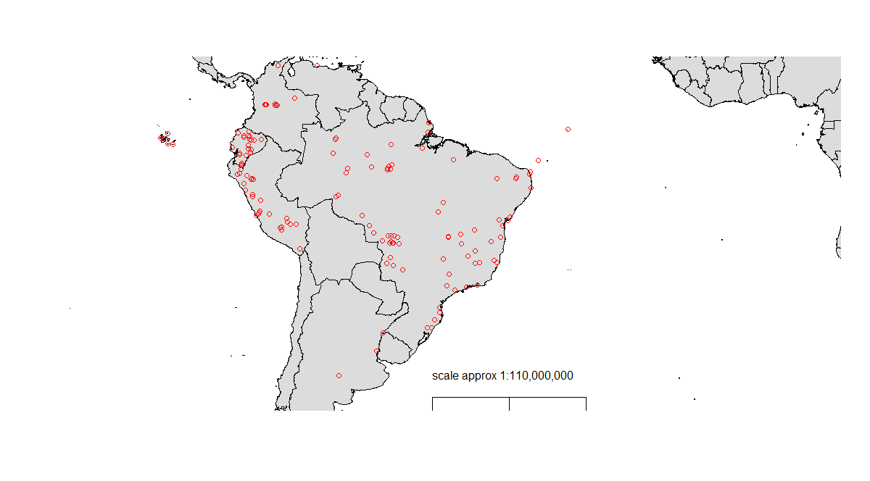 Figure 1: Bird collection points.

2.2 Correlations

*Spatial and temporal correlation*

All analyses were conducted in R (R Core Team, 2019). We determined whether there was significant spatial autocorrelation for prevalence and parasite richness in our dataset by calculating the Moran Index value. In order to estimate this index, we combined the coordinates data into a matrix and employed the function “Moran.I” from the “Ape” package in R. Temporal correlation analyses were performed using linear models. For prevalence, we conducted a mixed linear model using package “lme4” and the function “lmer”. Firstly, we grouped the data by year and location employing the “group_by” function from the “dplyr” package. Then, we compared the prevalence per year of collection considering number of birds collected and location as variables. For parasite richness, we performed a simple linear model using the “lm” function.

*Phylogenetic Signal*

In order to estimate the phylogenetic signal among prevalence and richness estimates for the bird species in our dataset, we downloaded the file AllBirdsHackett1.tre from <https://birdtree.org/> website. Using the “treeman” package, we created a treeman file containing all trees from the original file. Then, we randomly selected 100 trees. This new file was converted from treeman to a phylo file, from which we extracted one single random tree. Using “dplyr” package, we grouped our data per species and eliminated all bird species from the phylo tree which were not present in our dataset. Using the “match” function from the “picante” package, we matched the species between the tree and our dataset. Then, we calculated lambda (λ) to evaluate the phylogenetic signal among bird species in our dataset, for both haemosporidian prevalence and species richness. In order to estimate lambda (λ), we applied the “phylosig” function from the “phytools” package.

2.3 Statistical Analyses

*Bayesian model*

In order to determine whether migratory birds spread parasite lineages along their migratory routes and to evaluate the parasite connectivity among localities due to migratory behavior, we conducted Bayesian analyses using the “brms” package to evaluate the percentage of localities in which haemosporidian lineages occurred depending on whether they were found only in resident birds, only in partial migrant and fully migrant birds, or in both residents and migrants. Firstly, using the “ape” package, we computed the phylogenetic expected variances and covariances from our bird species and incorporated this to control for phylogenetic effects in our Bayesian model. Secondly, we applied the “get_priors” function to fit the priors for our model. We used as fixed variables the number of birds per site and parasite richness. As our Moran Index value for spatial autocorrelation of parasite richness among localities was low (-0.0008), we did not consider locality as a variable in our model and also did not use model correction for locality coordinates. Thus, we ran the model applying the “Beta” family, 4 chains with 2000 total iterations per chain and 50% of warmup interactions. The model results were plotted using the “conditional_effects” function.

*Mixed models*

Two mixed models were performed to estimate whether localities with more migratory birds have greater prevalence and richness of haemosporidian lineages. With this objective, we employed the “lmer” function from “lme4” package. In the first model, we considered parasite richness as the dependent variable and percentage of migratory bird species out of all species present in a locality as the independent variable. The number of bird species occurring in a locality was obtained from ?????. Ideally, the abundance of migratory and non-migratory species would also be used to obtain a weighed measure of the local importance of migrants; however, local abundance data were unavailable. Local host richness and prevalence were considered fixed variables and number of samples per site was used as a random variable.

In the second model, we analyzed the prevalence of infection in each bird species between localities using biome and locality as random variables. For this we considered local prevalence in each bird species as our dependent variable, species as a factor of prevalence and local percentage of migratory birds as our independent variable. In this model, we filtered our data in order to include only species with 10 or more apparitions. Apart from that, we employed the “trendline” function from the “basictrendline” package in R to create a trend plot. In this step, we again used prevalence as our dependent variable, species as a factor of prevalence and percentage of migratory birds as our independent variable.

3. Results

Our analyses demonstrate that bird migratory behavior increases the distribution of haemosporidian lineages but does not increase local richness and prevalence of these parasites in avian hosts. Our Bayesian model analyses revealed the lineages shared by resident and migratory species are the most widespread spatially, as they are found in a higher percentage of locations (Figure 2). We also demonstrate that the lineages shared by all three categories (resident, partial migrants and full migrants) are the most widespread, followed by those shared between residents and either type of migratory species. Nevertheless, despite the fact lineages shared by migratory species and residents are more widely distributed, lineages present in only residents, migratory or partially migratory species show similar spatial distribution in our model.

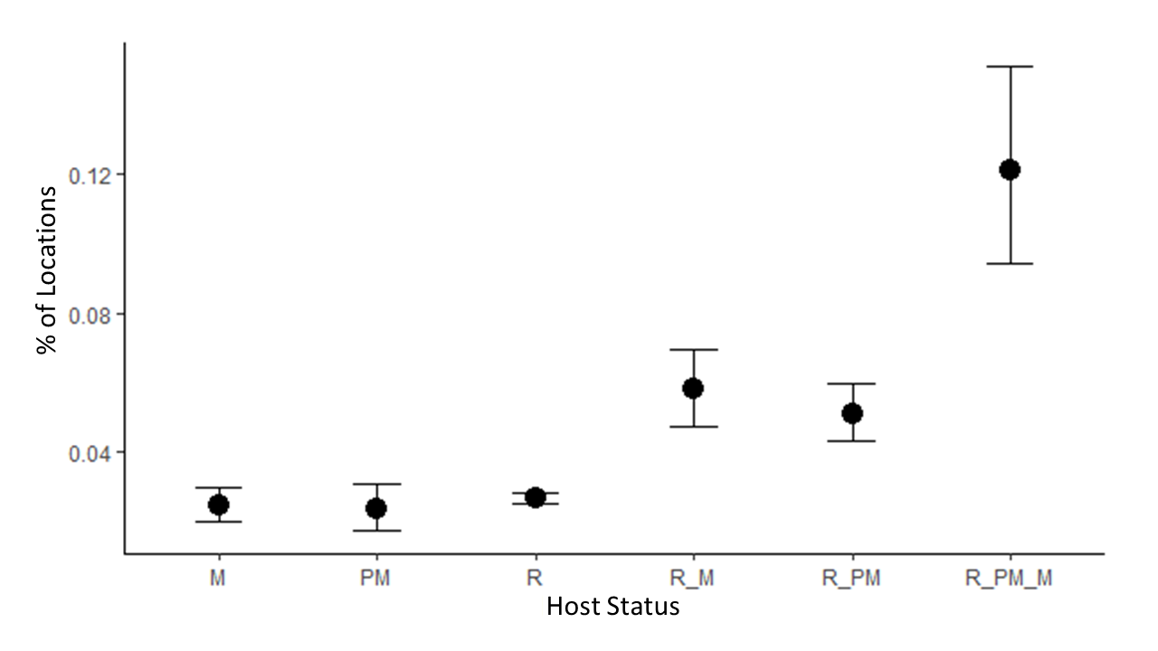

Figure 2: Bayesian model plot. Model demonstrates lineages shared by migratory species and resident are more spread as there are found in a higher percentage of locations. M = migratory, PM = partial migratory and R = resident.

Our first mixed model revealed that there is no correlation between the percentage/presence of migratory bird species in a locality and local parasite richness (p = 0.48, Figure 3). We also did not observe a correlation between migratory behavior and prevalence of haemosporidian parasites per species (p=0.11). Trendline analyses illustrates a straight line as the percentage of migrant species increases, demonstrating the absence of relation between migration behavior and prevalence per species (Figure 4).

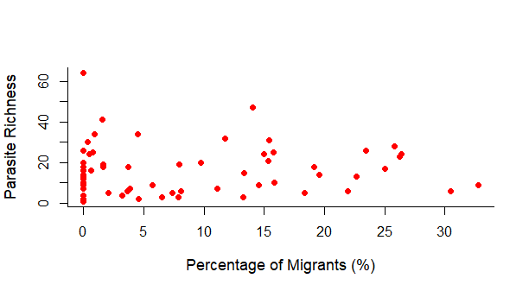

Figure 3: Correlation between percentage of migrants and parasite richness.

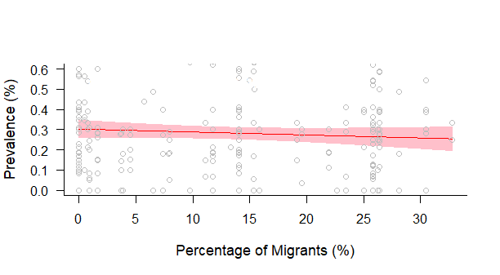

Figure 4: Correlation between percentage of migrants and prevalence per specie. Trendline demonstrates the absence of relation between migration behavior and prevalence per species.

The spatial and temporal autocorrelation analyses revealed there is no substantial effect of time or space on parasite richness, however, for prevalence, we observed a Moran Index effect of 0.15, and for this reason, locality was used as a random effect in our second mixed model. Likewise, considerable phylogenetic signals were observed among bird species for prevalence (0.49) and parasite richness (0.17). Considering this, phylogenetic covariation was added in Bayesian analyses and species were used as factors in the second mixed model.

References

Alekseev, A.N., Dubinina, H. V, Semenov, A. V, Bolshakov, C. V, 2001. Evidence of Ehrlichiosis Agents Found in Ticks ( Acari : Ixodidae ) Collected from Migratory Birds Evidence of Ehrlichiosis Agents Found in Ticks ( Acari : Ixodidae ) Collected from Migratory Birds. J. Med. Entomol. 38, 471–474. https://doi.org/10.1603/0022-2585-38.4.471

Altizer, S., Bartel, R., Han, B.A., 2011. Animal migration and infectious disease risk. Science (80-. ). 331, 296–302. https://doi.org/10.1126/science.1194694

Bauer, S., Hoye, B.J., 2014. Migratory animals couple biodiversity and ecosystem functioning worldwide. Science (80-. ). 344. https://doi.org/10.1126/science.1242552

Braga, É.M., Silveira, P., Belo, N.O., Valkiunas, G., 2011. Recent advances in the study of avian malaria: An overview with an emphasis on the distribution of Plasmodium spp in Brazil. Mem. Inst. Oswaldo Cruz 106, 3–11. https://doi.org/10.1590/S0074-02762011000900002

Callaway, R.M., Ridenour, W.M., 2004. Novel weapons: Invasive success and the evolution of increased competitive ability. Front. Ecol. Environ. 2, 436–443. https://doi.org/10.1890/1540-9295(2004)002[0436:NWISAT]2.0.CO;2

Comitê Brasileiro de Registros Ornitológicos - CRBO, 2014. Listas das aves do brasil. Com. Bras. Regist. Ornitológicos 1–38.

Fallon, A.S.M., Ricklefs, R.E., Swanson, B.L., Bermingham, E., 2003. Detecting Avian Malaria : an Improved Polymerase Chain Reaction Diagnostic Detecting Avian Malaria : an Improved Polymerase Chain 89, 1044–1047. https://doi.org/10.1645/GE-3157

Fecchio, A., Chagas, C.R.F., Bell, J.A., Kirchgatter, K., 2020. Evolutionary ecology, taxonomy, and systematics of avian malaria and related parasites. Acta Trop. 105364. https://doi.org/10.1016/j.actatropica.2020.105364

Ferreira-Junior, F.C., de Angeli Dutra, D., Silveira, P., Pacheco, R.C., Witter, R., de Souza Ramos, D.G., Pacheco, M.A., Escalante, A.A., Braga, E.M., 2018. A new pathogen spillover from domestic to wild animals: Plasmodium juxtanucleare infects free-living passerines in Brazil. Parasitology 1–10. https://doi.org/10.1017/S003118201800077X

Ferreira, F.C., Rodrigues, R.A., Sato, Y., Borges, M.A.Z., Braga, É.M., 2016. Searching for putative avian malaria vectors in a Seasonally Dry Tropical Forest in Brazil. Parasites and Vectors 9. https://doi.org/10.1186/s13071-016-1865-y

Hellgren, O., Waldenstro, J., Bensch, S., 2004. A New Pcr Assay For Simultaneous Studies Of Leucocytozoon, Plasmodium, And Haemoproteusfrom Avian Blood 90, 797–802. https://doi.org/10.1645/GE-184R1

Hellgren, O., Waldenström, J., Peréz-Tris, J., Szöll Ösi, E., Hasselquist, D., Krizanauskiene, A., Ottosson, U., Bensch, S., 2007. Detecting shifts of transmission areas in avian blood parasites - A phylogenetic approach. Mol. Ecol. 16, 1281–1290. https://doi.org/10.1111/j.1365-294X.2007.03227.x

Lindeborg, M., Barboutis, C., Ehrenborg, C., Fransson, T., Jaenson, T.G.T., Lindgren, P.-E., Lundkvist, Å., Nyström, F., Salaneck, E., Waldenström, J., Olsen, B., 2012. Migratory Birds, Ticks, and Crimean-Congo Hemorrhagic Fever Virus. Emerg. Infect. Dis. 18, 2095–2097. https://doi.org/10.3201/eid1812.120718

Marzal, A., 2012. Recent Advances in Studies on Avian Malaria Parasites. Malar. Parasites 135–158. https://doi.org/10.5772/33730

Morshed, M.G., Scott, J.D., Fernando, K., Beati, L., Mazerolle, D.F., Geddes, G., Durden, L.A., 2005. Migratory songbirds disperse ticks across Canada, and first isolation of the Lyme disease spirochete, Borrelia burgdorferi, from the avian tick, Ixodes auritulus. J. Parasitol. 91, 780–790. https://doi.org/10.1645/GE-3437.1

O’Connor, E.A., Hasselquist, D., Nilsson, J.Å., Westerdahl, H., Cornwallis, C.K., 2020. Wetter climates select for higher immune gene diversity in resident, but not migratory, songbirds. Proceedings. Biol. Sci. 287, 20192675. https://doi.org/10.1098/rspb.2019.2675

Poupon, M., Lommano, E., Douet, V., Rais, O., Schaad, M., Jenni, L., Gern, L., 2006. Prevalence of Borrelia burgdorferi Sensu Lato in Ticks Collected from Migratory Birds in Switzerland Prevalence of Borrelia burgdorferi Sensu Lato in Ticks Collected from Migratory Birds in Switzerland. Appl. Environ. Microbiol. 72, 976–979. https://doi.org/10.1128/AEM.72.1.976

Prenter, J., MacNeil, C., Dick, J.T.A., Dunn, A.M., 2004. Roles of parasites in animal invasions. Trends Ecol. Evol. 19, 385–390. https://doi.org/10.1016/j.tree.2004.05.002

Ricklefs, R.E., Medeiros, M., Ellis, V.A., Svensson-Coelho, M., Blake, J.G., Loiselle, B.A., Soares, L., Fecchio, A., Outlaw, D., Marra, P.P., Latta, S.C., Valkiūnas, G., Hellgren, O., Bensch, S., 2017. Avian migration and the distribution of malaria parasites in New World passerine birds. J. Biogeogr. 44, 1113–1123. https://doi.org/10.1111/jbi.12928

Somenzari, M., Amaral, P.P. do, Cueto, V.R., Guaraldo, A.D.C., Jahn, A.E., Lima, D.M., Lima, P.C., Lugarini, C., Machado, C.G., Martinez, J., Nascimento, J.L.X. do, Pacheco, J.F., Paludo, D., Prestes, N.P., Serafini, P.P., Silveira, L.F., Sousa, A.E.B.A. de, Sousa, N.A. de, Souza, M.A. de, Telino-Júnior, W.R., Whitney, B.M., 2018. An overview of migratory birds in Brazil, Papéis Avulsos de Zoologia. https://doi.org/10.11606/1807-0205/2018.58.03